
A MINI PROJECT REPORT
ON
SMART GARBAGE DETECTION SYSTEM
BACHELOR OF TECHNOLOGY
in
Computer Science & Engineering (AIML)
Submitted By
Abhinav Singh (2501921530012)
Abhinav Srivastava (2501921530013)
Abhishek Maurya (2501921530018)
Abhishek Kumar Gupta (2501921530016)
Under the Supervision of
Dr. Santosh Srivastava
G.L. BAJAJ INSTITUTE OF TECHNOLOGY & MANAGEMENT, GREATER NOIDA

Affiliated to
DR. A.P.J. ABDUL KALAM TECHNICAL UNIVERSITY, LUCKNOW

Session 2026-2027
CERTIFICATE

This is to certify that the Mini Project report entitled “Smart Garbage Detection System” done by Abhinav Singh (2501921530012), Abhinav Srivastava (2501921530013), Abhishek Maurya (2501921530018) and Abhishek Kumar Gupta (2501921530016) is an original work carried out by them in the Department of Computer Science and Engineering (AIML), G.L. Bajaj Institute of Technology & Management, Greater Noida under the supervision of Dr. Santosh Srivastava. The matter embodied in this project work has not been submitted earlier for the award of any degree or diploma to the best of knowledge and belief.

Date:

Dr. Santosh Srivastava Dean / Head of Department
Associate Professor

ACKNOWLEDGEMENT
The authors express sincere gratitude to the project guide, Dr. Santosh Srivastava, for the valuable guidance and support extended throughout the duration of this project. The versatile knowledge and constructive feedback provided have been instrumental during the critical phases of this work.
Special thanks are extended to the Head of the Department, Dr. Santosh Kumar Srivastava, for the constant support and encouragement received during the course of this project.
The authors also take this opportunity to express gratitude to all faculty members, friends, and family who have directly or indirectly supported the completion of this project.

Abhinav Singh
Abhinav Srivastava
Abhishek Maurya
Abhishek Kumar Gupta
ABSTRACT
Overflowing dustbins and roadside litter remain a persistent hygiene hazard in campuses and urban localities. Manual inspection rounds are slow and labour-intensive, while dedicated Internet of Things (IoT) smart-bin sensors are accurate but costly to install and maintain at scale. This project presents a camera enabled smart device as an artificial-intelligence-powered Internet Protocol (IP) camera. The system streams camera over a local Wi-Fi network using the HTTP/RTSP protocol to a Python-based inference engine running the YOLOv8 object detection model.
Two independent regions of interest (ROI) are analysed in real time: a bin-interior ROI, from which the fill level of the dustbin is estimated as a percentage of detected object coverage, and a surrounding floor ROI, which is monitored for litter or overflow. When a configured threshold is crossed, the system automatically captures an annotated snapshot and dispatches a formatted Hypertext Markup Language (HTML) alert e-mail to the concerned admin or caretaker through the Simple Mail Transfer Protocol (SMTP), with a time-based cooldown to prevent inbox flooding. A standalone calibration utility allows the region-of-interest boundaries to be marked interactively by dragging, eliminating the need for manual coordinate entry.
The proposed system demonstrates that a camera enabled device, combined with open-source computer vision, can deliver automated, real-time garbage monitoring and alerting without any dedicated per-bin sensor hardware, thereby offering a scalable and low-cost solution for municipal and campus waste management.

TABLE OF CONTENT
Certificate (ii)
Acknowledgement (iii)
Abstract (iv)
Table of Content (v)
List of Figures (vii)
List of Tables (viii)
Chapter 1 Introduction 1
1.1 Introduction 1
1.2 Project Overview 1
1.3 Existing System 2
1.4 Proposed System 3
1.5 Unique Features of the Proposed System 5
Chapter 2 Requirement Analysis and System Specification 6
2.1 Introduction 6
2.2 Functional Requirements 6
2.3 Data Requirements 8
2.4 Performance Requirements 8
2.5 SDLC Model to be Used 8
2.6 Use Case Diagram 9
Chapter 3 System Design 12
3.1 Introduction 12
3.2 Design Approach 12
3.3 Design Diagrams 12
3.4 User Interface Design 13
3.5 Database Design and Processing Flowchart 14
Chapter 4 Implementation 16
4.1 Introduction 16
4.2 Tools / Technologies Used 16
4.3 Coding Standards of the Programming Language Used 19
Chapter 5 Result and Discussion 20
5.1 Introduction 20
5.2 Snapshots of System 20
5.3 Snapshots of Database Tables 24
Chapter 6 Conclusion, Limitation and Future Scope 25
6.1 Conclusion …………………………………………………………………..25
6.2 Limitation …………………………………………………………….……..25
6.3 Future Scope ………………………………………………………………..26
References 27
Plagiarism Report 28

LIST OF FIGURES
Figure No. | Description | Page No.
Fig. 1.1 | Overall Working Flow of the Smart Garbage Detection System | 4
Fig. 2.1 | Iterative and Incremental SDLC Model Adopted for the Project | 9
Fig. 2.2 | Use case diagram of the Smart Garbage Detection System | 11
Fig. 3.1 | System Architecture / Data Flow Diagram | 13
Fig. 3.2 | Dual Region of Interest | 14
Fig. 3.3 | Processing Flowchart | 15
Fig 5.1 | Application Dashboard | 21
Fig 5.2 | Adding E-mail or Caretaker E-mail | 21
Fig 5.3 | Registering New Dustbins | 22
Fig 5.4 | Bin Monitoring | 22
Fig 5.5 | Detection of Garbage and Showing Results | 23
Fig 5.6 | Capturing screenshots & Sending E-mail | 23
Fig 5.7 | Database Schema | 24

LIST OF TABLES
Table No. | Description | Page No.
Table 1.1 | Summary of Literature Survey | 2
Table 2.1 | Functional Requirements of the system | 7
Table 2.2 | Description of use cases | 10
Table 4.1 | Hardware Used | 17
Table 4.2 | Software And Libraries Used | 17
Table 4.3 | Core Modules of the Project | 18

Chapter 1

Introduction

1.1 Introduction

Existing bin-monitoring approaches rely either on dedicated hardware sensors mounted inside each bin or on manual human patrol rounds, and neither approach scales affordably across the many bins spread over a large campus or locality. Overflow inside a bin and litter on the surrounding floor are two related failure modes that are rarely monitored together, and there is presently no low-cost way to detect both problems automatically and notify the concerned authority in real time.
Given the high cost and poor scalability of dedicated smart-bin hardware, and the slow and inconsistent response of manual inspection, a clear need exists for a low-cost, artificial-intelligence-driven alternative that can continuously and automatically monitor both the fill level of a dustbin and the cleanliness of its surrounding floor area using only a camera and open-source computer vision, and that can alert the concerned authority in real time without deploying any specialised per-bin sensor.

1.2 Project Overview

Indian cities generate well over 1.5 lakh metric tonnes of municipal solid waste every single day, and global waste generation is projected to rise from 2.01 to 3.4 billion tonnes annually by 2050. Waste disposal behaviour is largely reactive: bins are rarely cleared the moment they overflow, so litter spreads before it is noticed, and caretaking staff, who juggle many duties, check bins on a fixed schedule rather than on actual need, causing avoidable delays.
The present project repurposes a camera enabled smart device as an artificial-intelligence-powered IP camera. Running the YOLOv8 object detection model, the system continuously tracks a dustbin's fill level and watches the surrounding floor for litter or overflow, and then e-mails an annotated alert to the caretaker the instant a threshold is crossed, at zero additional hardware cost and with a no-code, drag-and-define calibration tool.
1. 3 Existing System

Four broad categories of existing solutions were examined during the literature survey. Ultrasonic or infrared bin sensors mounted inside each bin measure the fill level directly but require per-bin wiring, batteries and ongoing maintenance. Internet of Things smart-bin nodes, built around microcontrollers such as ESP32 or Arduino boards connected to a cloud dashboard, are accurate but costly to scale across many bins. Closed-circuit television (CCTV) based manual monitoring, where staff watch live camera feeds to spot overflow, is slow, labour-intensive and error-prone, and is not conducted in real time. Citizen complaint applications, such as municipal corporation complaint systems, are reactive and depend on people reporting issues only after they occur.
Table 1.1 Summary of Literature Survey
S. No. | Source and Year | Summary
1 | Abo-Zahhad et al. (2025) [1] | Have discussed a real-time garbage monitoring approach using YOLOv8 and YOLOv5 two-stage lightweight models that classify bin fill status and flag litter outside containers, while assuming continuous power availability.
2 | Dong et al. (2025) [5] | Have proposed a dynamic-perception YOLO variant (Cot-DCN-YOLO) for bin detection with an enhanced architecture that improves detection accuracy in cluttered, occluded real-world street-view scenes.
3 | Arthur et al. (2024) [3] | Have surveyed smart dustbin systems based on the Internet of Things and deep learning, and have concluded that most such systems demand constant maintenance, making municipal-scale rollout costly.
4 | Sun et al. (2023) [2] | Have reported an improved garbage detection model, YOLOv5-OCDS, that fuses camera, ultrasonic sensor, Global Positioning System (GPS) and LoRa modules on a Raspberry Pi, resulting in higher hardware complexity.

The gap identified from the survey is that most existing solutions need dedicated sensors or continuous manual watching per bin; none of them combine camera with artificial intelligence to deliver a zero-hardware-cost, automated alert system.

1.4 Proposed System

The proposed system streams the IP webcam over the local Wi-Fi network to a Python-based artificial intelligence engine using the HTTP/RTSP protocol, requiring no dedicated camera hardware. Two independent regions of interest are then processed by the YOLOv8 detector: a bin-interior ROI, from which the percentage fill level is estimated from detected object coverage, and a surrounding floor ROI, which is analysed for litter or overflow objects. When a configured threshold is breached, the system captures an annotated snapshot and dispatches a formatted HTML e-mail to the admin or caretaker through SMTP, applying a time-based cooldown after each alert to prevent inbox flooding, together with periodic status summaries regardless of threshold state.
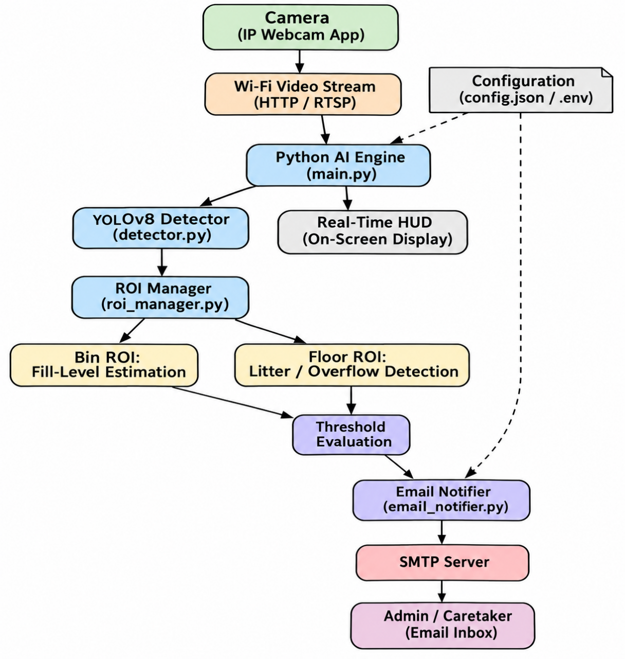
Figure 1.1 – Overall Working Flow of the Smart Garbage Detection System

1.5 Unique Features of the Proposed System

- Develop an AI-enabled monitoring system that uses an existing device as an IP camera for real-time video surveillance.
- Simultaneous monitoring of two related failure modes, namely bin overflow and surrounding floor litter, through a dual region-of-interest processor.
- Real-time, automated e-mail alerting with an annotated snapshot, eliminating dependence on manual inspection rounds.
- A standalone, no-code calibration utility that allows region-of-interest boundaries to be marked interactively by dragging, without manual coordinate entry.
- A cooldown mechanism and periodic status summaries that prevent inbox flooding while keeping the caretaker continuously informed.

Chapter 2

Requirement Analysis and System Specification

2.1 Introduction

This chapter presents the functional and performance requirements of the Smart Garbage Detection System, along with the data requirements, the software development life cycle (SDLC) model adopted, and the use case diagram describing the interaction between the admin/caretaker and the system.
2.2 Functional Requirements

Indian cities generate well over 1.5 lakh metric tonnes of municipal solid waste every single day, and global waste generation is projected to rise from 2.01 to 3.4 billion tonnes annually by 2050. Waste disposal behaviour is largely reactive: bins are rarely cleared the moment they overflow, so litter spreads before it is noticed, and caretaking staff, who juggle many duties, check bins on a fixed schedule rather
- The system shall connect to and continuously receive a video stream from the camera over the local Wi-Fi network.
- The system shall run YOLOv8 object detection on the bin-interior region of interest and estimate the fill level as a percentage in real time.
- The system shall run the same detector on a separate floor region of interest to flag litter or overflow objects outside the bin.
- The system shall capture an annotated snapshot and dispatch a formatted e-mail alert via SMTP whenever a configured threshold is breached.
- The system shall apply a time-based cooldown after each alert and shall optionally dispatch periodic status summaries.
Table 2.1 – Functional Requirements of the System
ID | Requirement | Description
FR1 | Camera Streaming | The camera enabled device feed over the local Wi-Fi network using the IP Webcam application.
FR2 | Video Acquisition | The Python AI engine must connect to the HTTP/RTSP stream and continuously acquire video frames.
FR3 | Object Detection | Each acquired frame must be processed using the YOLOv8 model to detect relevant objects and their bounding boxes.
FR4 | ROI Processing | The system must restrict analysis of detections to the configured Bin ROI and Floor ROI.
FR5 | Fill-Level Estimation | The system must estimate the dustbin fill percentage from object coverage within the Bin ROI.
FR6 | Overflow / Litter Detection | The system must flag objects detected within the Floor ROI as litter or overflow.
FR7 | Threshold Comparison | The system must compare the estimated fill percentage and litter status against configurable thresholds.
FR8 | Email Generation | On threshold breach, the system must generate a formatted email containing the fill percentage, litter status, detected object details, timestamp and annotated snapshot.
FR9 | Email Transmission | The system must transmit the generated alert email to the configured recipient using SMTP.
FR10 | Alert Cooldown | The system must enforce a minimum time interval between successive alert emails for the same condition.
FR11 | Status Reporting | The system must be able to send periodic status updates independent of threshold breaches.
FR12 | ROI Calibration | The system must provide a mechanism to interactively mark and update the Bin ROI and Floor ROI coordinates.

2.3 Data Requirements
- Live video frames received over HTTP/RTSP from the IP Webcam.
- Region-of-interest coordinates for the bin-interior area and the floor area, stored in a configuration file (config.json).
- Threshold values, cooldown duration and SMTP credentials, stored securely in an environment file (.env).
- Annotated snapshot images generated at the instant of an alert, attached to the outgoing e-mail.
2.4 Performance Requirements
- Object detection on each region of interest shall complete within a time budget that supports real-time, near-continuous monitoring.
- The system shall automatically attempt stream reconnection in the event of a temporary network interruption.
- Alert dispatch shall be rate-limited by a cooldown period so that the admin/caretaker inbox is not flooded during sustained threshold breaches.
- The system shall operate reliably using only a consumer-grade PC or laptop, with GPU acceleration treated as optional rather than mandatory.
2.5 SDLC Model to be Used
An iterative and incremental model was adopted for the development of this project. Core modules, namely the video-streaming interface, the YOLOv8 detector wrapper and the region-of-interest manager, were built and tested first using a synthetic/demo mock-stream script, after which the e-mail alerting module, the calibration utility and the visual heads-up display (HUD) were incrementally added and integrated. This model was chosen because it allowed each module to be verified independently before the complete pipeline was tested end-to-end with the physical camera.
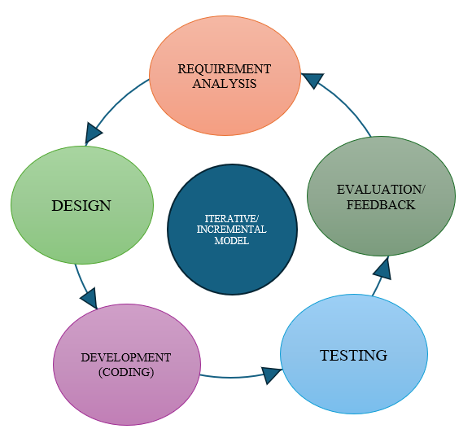
Figure 2.1 – Iterative and Incremental SDLC Model Adopted for the Project

2.6 Use Case Diagram
The admin/caretaker is the sole external actor of the system. The principal use cases are streaming the bin camera feed, estimating the fill level, detecting floor litter or overflow, calibrating the region-of-interest boundaries, and receiving the automatically dispatched alert e-mail, as shown in Fig. 2.1.

Table 2.2 – Description of Use Cases
Use Case | Primary Actor | Description
Stream Video from Camera | Camera | The camera feed to the AI engine over Wi-Fi.
Detect Objects in Bin ROI | AI Detection Engine | YOLOv8 detects objects that fall inside the configured Bin ROI.
Estimate Fill Level (%) | AI Detection Engine | The proportion of the Bin ROI covered by detected objects is converted into a fill percentage.
Detect Litter / Overflow in Floor ROI | AI Detection Engine | Objects detected inside the Floor ROI are flagged as litter or overflow.
Evaluate Threshold | AI Detection Engine | The current fill percentage and litter status are compared against configured thresholds.
Generate Annotated Snapshot | AI Detection Engine | An annotated image of the current frame is produced when a threshold is crossed.
Send Email Alert | Email Service (SMTP) | The annotated snapshot and status details are emailed to the administrator.
Apply Alert Cooldown | AI Detection Engine | Further alerts for the same condition are suppressed until the cooldown period elapses.
Calibrate ROI Coordinates | Admin / Caretaker | The administrator marks the Bin ROI and Floor ROI on a captured frame.
View Real-Time Status (HUD) | Admin / Caretaker | The administrator views the live on-screen overlay showing detection and status information.
Receive Periodic Status Report | Admin / Caretaker | The administrator receives status summaries independent of threshold breaches.
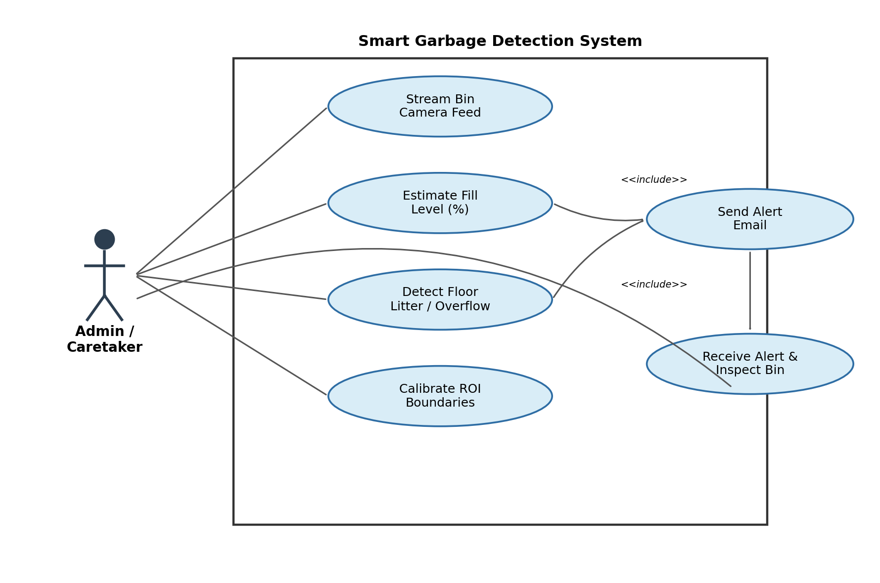

Fig. 2.2 Use Case Diagram of the Smart Garbage Detection System

Chapter 3

System Design

3.1 Introduction

This chapter describes the design approach, the overall system architecture, the user interface design and the data storage design adopted for the Smart Garbage Detection System.
3.2 Design Approach (Function Oriented)

A function-oriented, modular design approach was adopted, in which each major responsibility of the system is isolated into an independent Python module. This approach keeps the video-acquisition, detection, region-of-interest management, alerting and calibration responsibilities decoupled, allowing each module to be developed, tested and maintained independently while communicating through well-defined function calls and a shared configuration file.
3.3 Design Diagrams
The overall data flow of the system is illustrated in Fig. 3.1. The IP Webcam, streams feed over the local Wi-Fi network to the Python artificial intelligence engine. The engine forwards each frame to a dual region-of-interest processor, which separately computes the bin-interior fill percentage and the floor-area litter/overflow status. Both outputs feed a smart alerting and cooldown engine, which, on threshold breach, dispatches an SMTP e-mail carrying an annotated mage to the admin/caretaker inbox. A real-time visual heads-up display is also rendered on-screen for local monitoring.
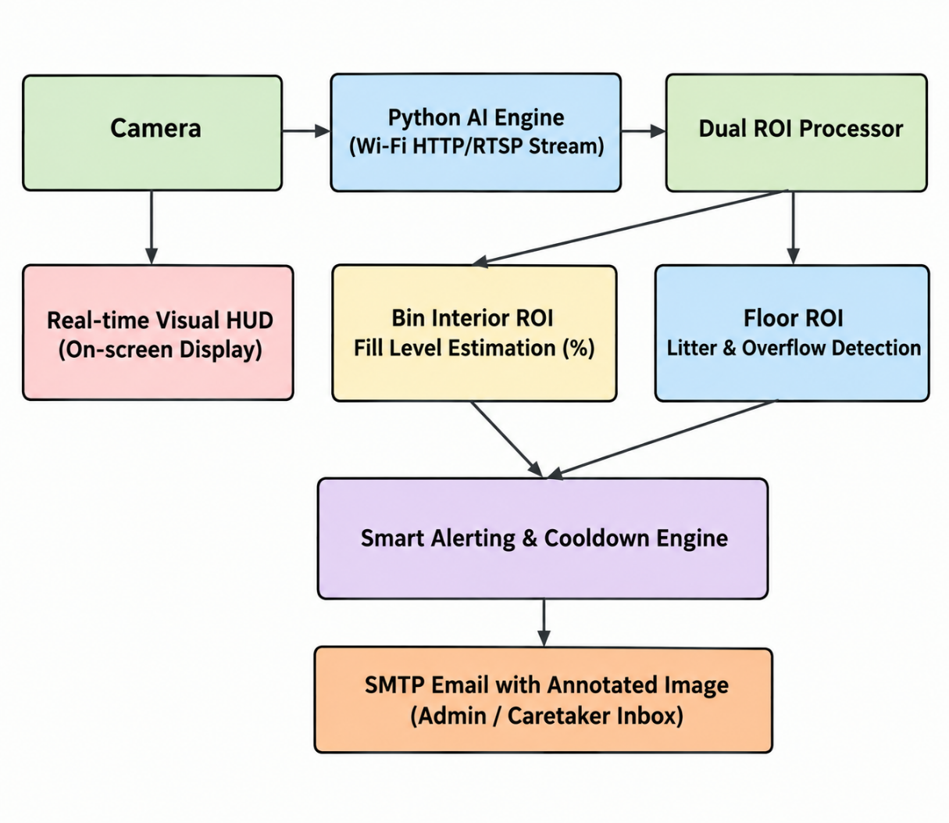
Fig. 3.1 System Architecture / Data Flow Diagram
3.4 User Interface Design
The system provides a real-time, on-screen visual heads-up display rather than a conventional graphical user interface. The display overlays the current bin fill percentage, the floor status (clear or littered), the bin-interior and floor region-of-interest boundaries, and a resilient-connection indicator directly on the live video feed. A separate standalone calibration screen allows the admin to mark the corners of both regions of interest by dragging them on a captured frame, with no manual coordinate entry required.
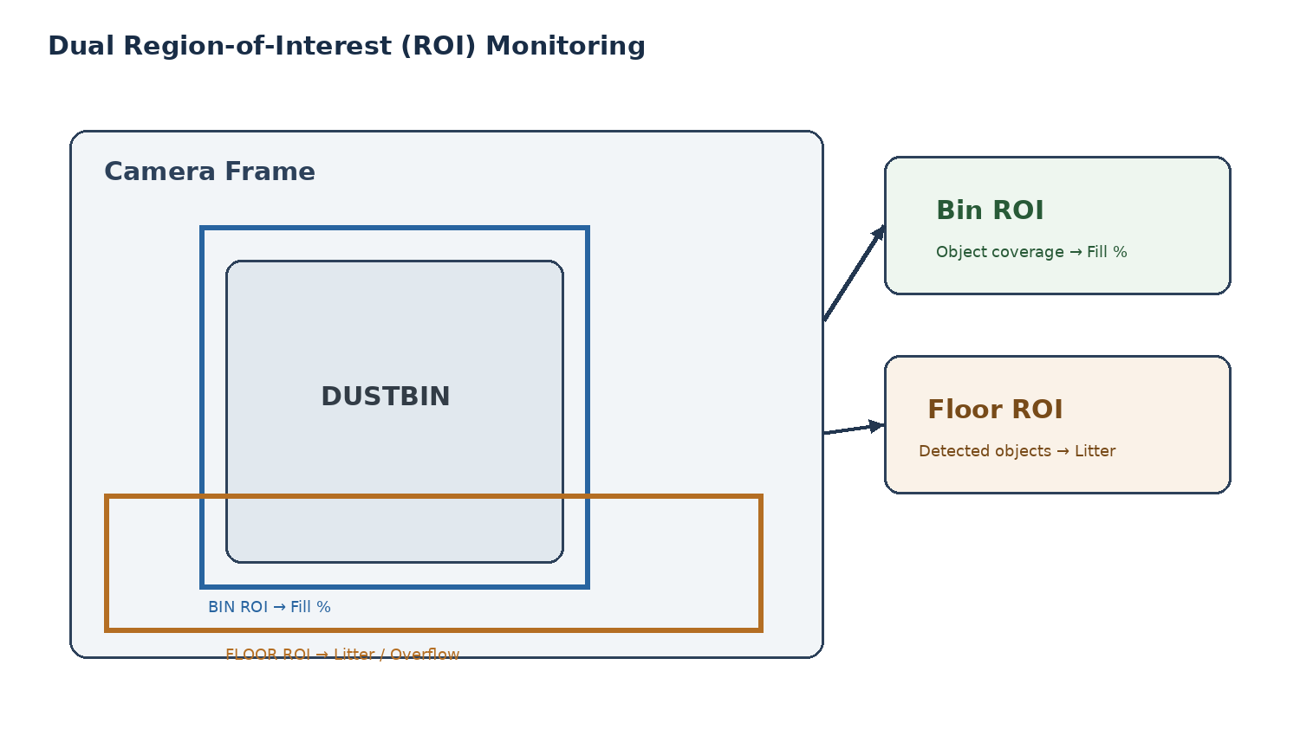
Fig. 3.2 Dual Region of Interest

3.5 Database Design and Processing Flowchart
The system does not employ a conventional relational or NoSQL database, since it is designed for real-time, stateless per-bin monitoring rather than long-term data persistence. Instead, all configurable parameters, namely the video stream Uniform Resource Locator (URL), the region-of-interest coordinates, the fill and litter thresholds, and the SMTP alert settings, are stored in a structured configuration file (config.json), while sensitive credentials such as the SMTP username and application password are stored separately and securely in an environment file (.env). This design keeps the deployment lightweight and portable across different bin locations.
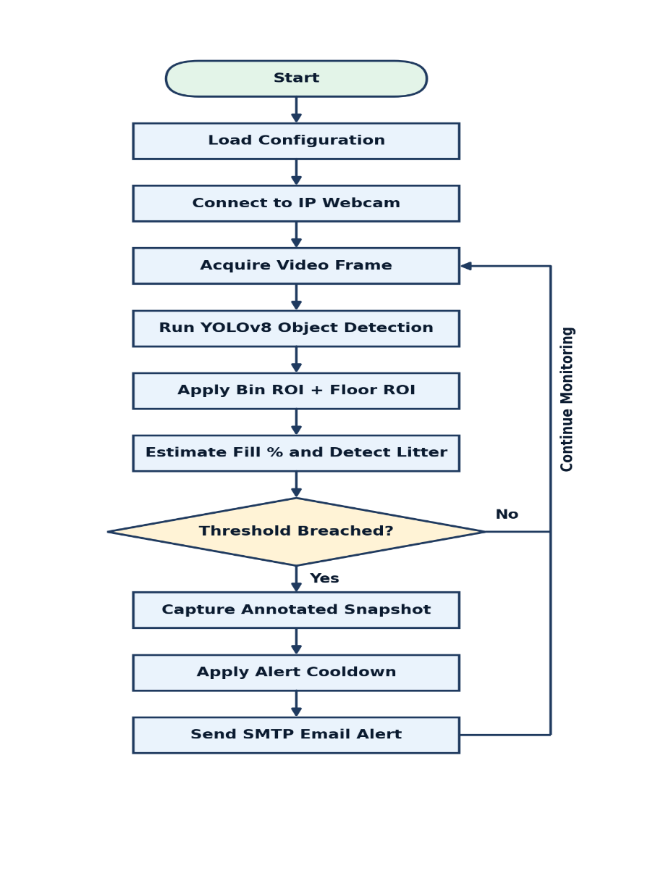
Fig. 3.3 Processing Flowchart

Chapter 4

Implementation

4.1 Introduction

This chapter describes the tools and technologies used to implement the Smart Garbage Detection System and the coding standards followed for the Python programming language used throughout the project.
4.2 Tools / Technologies Used
- Python 3.x runtime environment for the entire artificial intelligence engine.
- IP Webcam, streams HTTP/RTSP video from the camera.
- Ultralytics YOLOv8, used as the real-time object detection model.
- OpenCV, used for video capture, frame processing, and region-of-interest drawing.
- SMTP e-mail delivery via a Gmail application password, Outlook, or Yahoo, used for alert dispatch.
- Supporting libraries: python-dotenv, numpy and pillow.

Component | Role in the System
Camera | Acts as the network (IP) camera, capturing the live view of the dustbin and its surroundings.
Local Wi-Fi Router | Provides the network over which the video stream is transmitted from the phone to the PC.
PC / Laptop | Runs the Python AI engine that performs detection, estimation and alerting.
Table 4.1 – Hardware Used
Technology | Purpose
Python 3.x | Primary programming language used to implement all modules of the system.
IP Webcam (Android App) | Streams the smartphone's rear camera feed over HTTP/RTSP.
Ultralytics YOLOv8 | Performs real-time object detection on incoming video frames.
OpenCV | Handles video capture, frame processing, drawing of ROIs and bounding boxes, and the HUD overlay.
SMTP (Gmail / Outlook / Yahoo) | Used to transmit the formatted alert email to the administrator.
python-dotenv | Loads sensitive configuration values (SMTP credentials) from a .env file.
Table 4.2 – Software and Libraries Used
Module | Description
main.py | Main application loop; performs resilient stream reconnection, renders the HUD overlay, and dispatches periodic status and instant alert triggers.
detector.py | YOLOv8 inference wrapper; filters garbage/waste classes (from COCO or a custom Roboflow-trained model) and flags overflow/littering.
roi_manager.py | Handles bin-interior and floor region-of-interest coordinate mathematics, intersection with detected boxes, and fill-percentage estimation.
email_notifier.py | Formats HTML/plain-text alert e-mails with fill percentage, floor status, object counts, the annotated image and cooldown control.
calibrate_roi.py | Standalone tool used to capture a test frame and interactively mark region-of-interest boundaries by dragging.
config.json / .env | Stores the stream URL, region-of-interest coordinates, thresholds, e-mail settings and secure SMTP credentials.
test_mock_stream.py | Provides synthetic/demo frames used to validate the pipeline end-to-end before the physical camera is set up.
Table 4.3 Core Modules of the System
4.3 Coding Standards of the Programming Language Used
- Each module is restricted to a single, clearly defined responsibility, following the single-responsibility principle common to modular Python design.
- Configuration values (thresholds, coordinates, credentials) are never hard-coded; they are read from config.json or the .env file at runtime.
- Descriptive function and variable names are used throughout, consistent with standard PEP 8 Python style conventions.
- Network and stream-reading operations are wrapped in exception handling to support resilient reconnection without crashing the main loop.
- A synthetic mock-stream script is maintained so that the complete pipeline can be tested without depending on the physical camera.

Chapter 5

Result and Discussion

5.1 Introduction

This chapter presents the outcomes observed upon running the Smart Garbage Detection System end-to-end, from the camera video stream through to the dispatch of an alert e-mail, and discusses these outcomes with reference to the objectives set out in Chapter 1.
5.2 Snapshots of System
The system was validated using the synthetic mock-stream script prior to deployment with the physical camera, confirming that the dual region-of-interest processor, the fill-percentage estimation, the floor litter/overflow detection, and the SMTP alert dispatch function correctly across the complete pipeline. Representative on-screen HUD snapshots (showing the live fill-percentage overlay and region-of-interest boundaries) and the annotated alert e-mail generated on threshold breach are to be inserted here at the time of physical deployment and field testing.
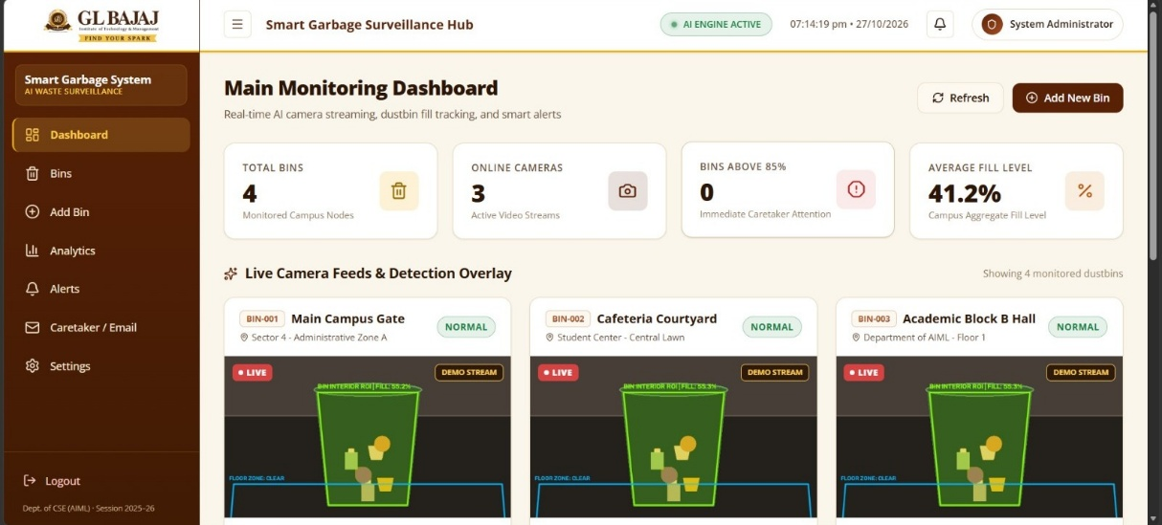 Fig 5.1 Application Dashboard
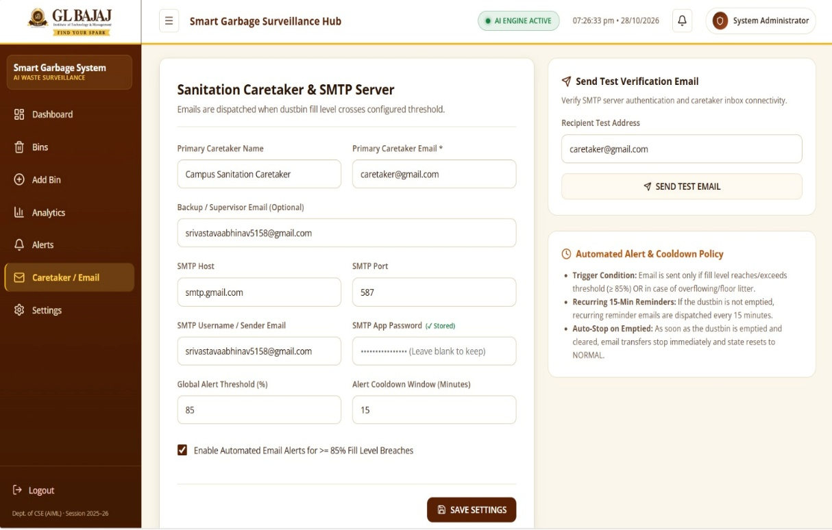 Fig 5.2 Adding E-mail or Caretaker E-mail
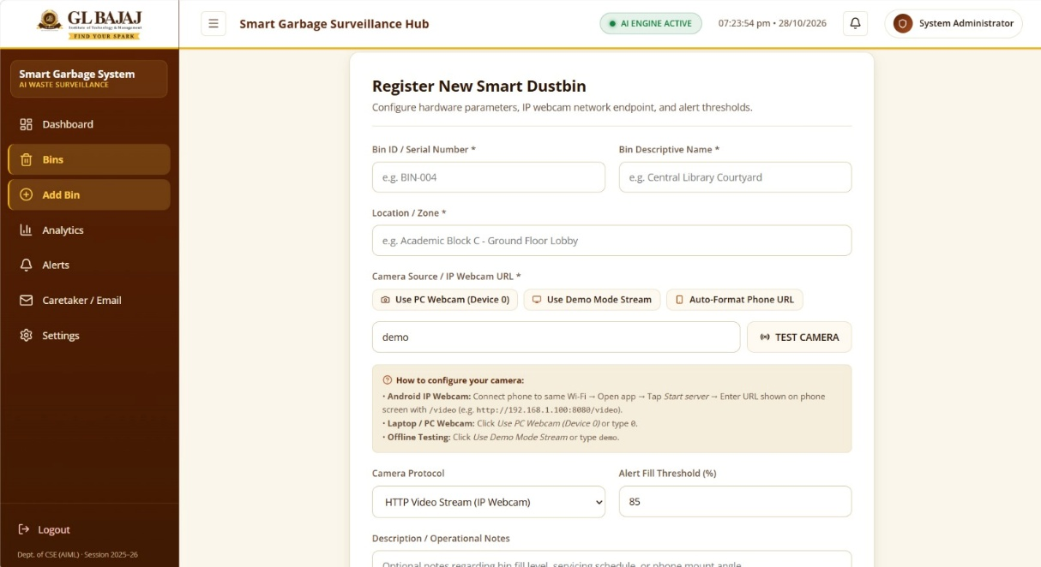 Fig 5.3 Registering New Dustbins
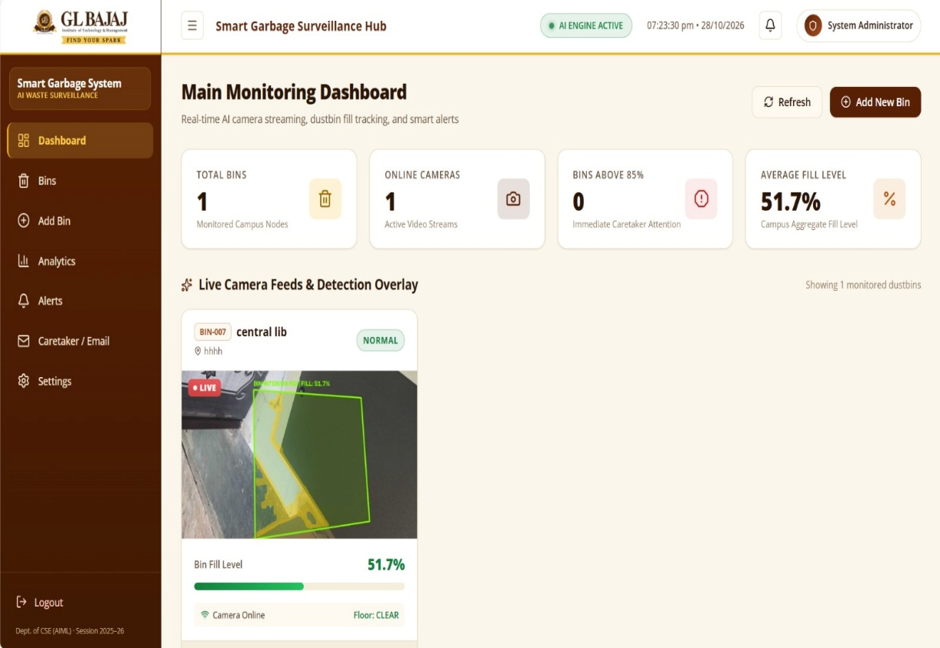 Fig 5.4 Bin Monitoring
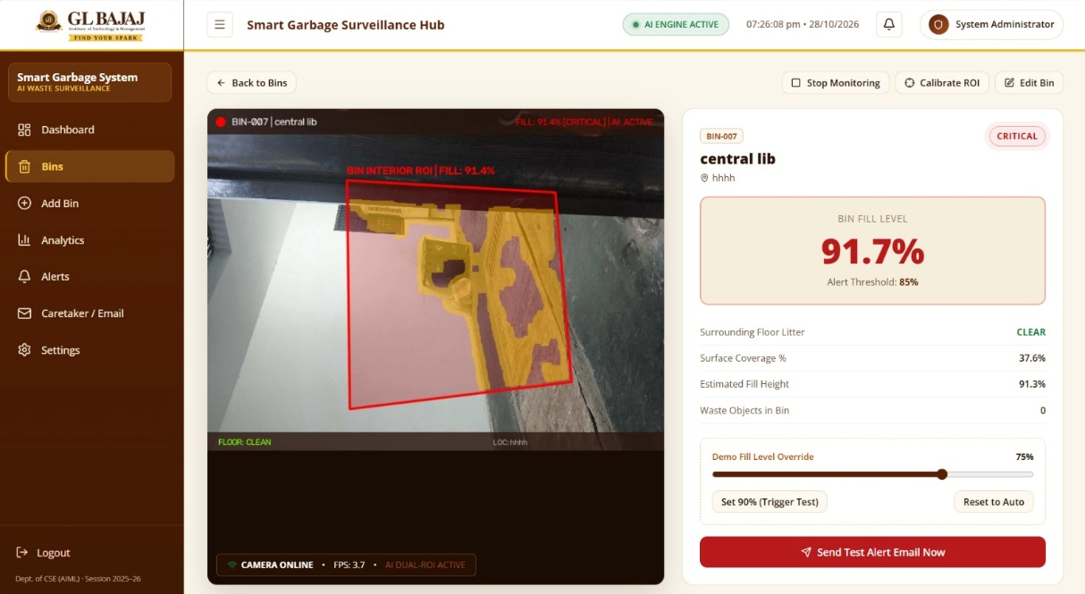 Fig 5.5 Detection of Garbage and Showing Results
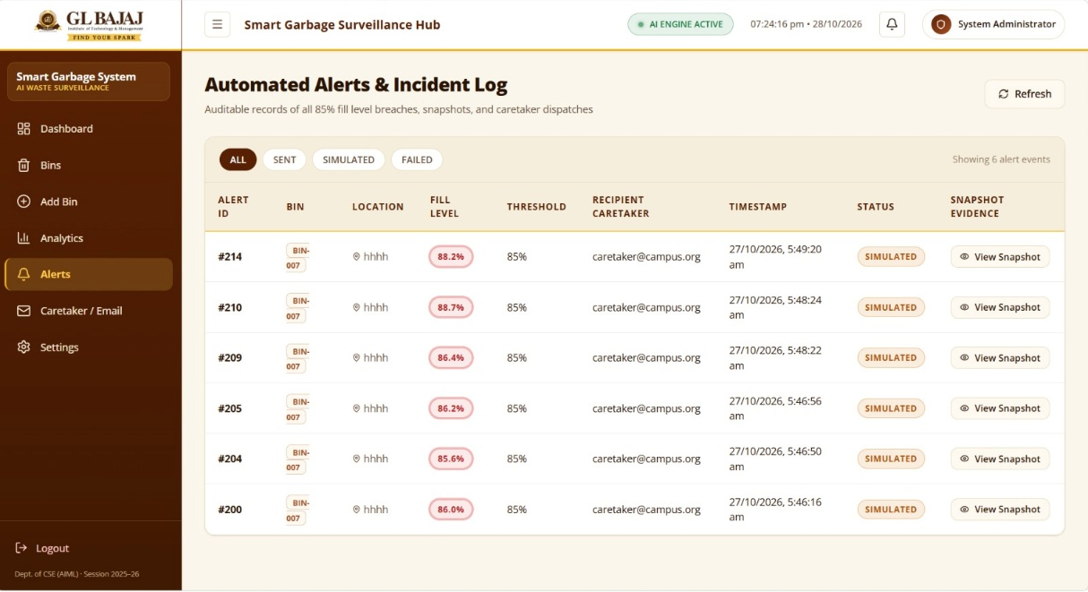 Fig 5.6 Capturing screenshots & Sending E-mail
5.3 Snapshots of Database Tables
As discussed in Section 3.5, the system does not employ a conventional database; configuration and threshold data are instead stored in config.json and .env files. A representative snapshot of the populated configuration file is to be inserted here to illustrate the stored region-of-interest coordinates, thresholds and alert settings.
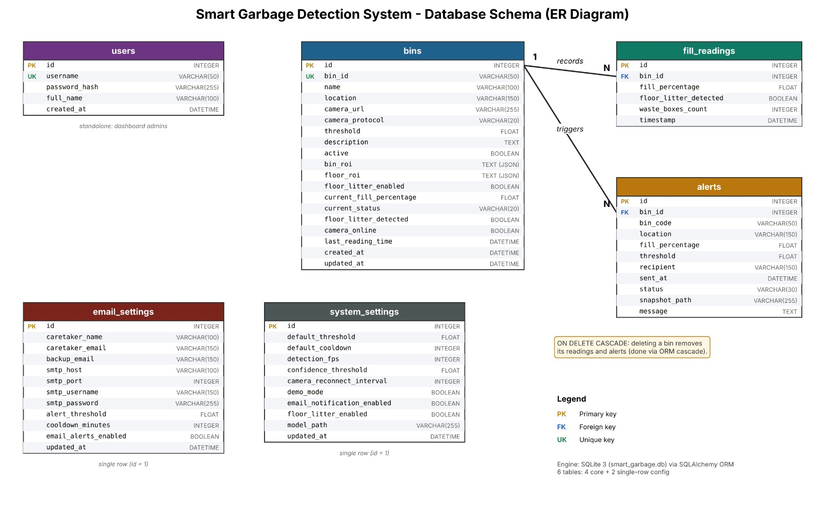 Fig 5.7 Database Schema

Chapter 6

Conclusion, Limitation and Future Scope

6.1 Conclusion

This project successfully uses a camera and open-source artificial intelligence, in the form of YOLOv8, to build a fully automated, zero-hardware-cost garbage monitoring and alerting system. By simultaneously tracking bin fill level and surrounding floor cleanliness, and by dispatching real-time e-mail alerts, the system reduces dependence on manual inspection and enables a substantially faster cleanup response than periodic manual rounds, thereby addressing the problem formulated in Chapter 1 at negligible additional hardware cost.
6.2 Limitation
- Detection accuracy depends on ambient lighting conditions and camera positioning, and may degrade in poorly lit or heavily occluded scenes.
- The system relies on generic COCO-trained classes unless a custom garbage-specific dataset is trained, which may limit precision for uncommon waste types.
- A stable local Wi-Fi connection and a continuously powered camera are required, making the system dependent on network and power availability.
- Each deployment currently monitors a single bin and its immediate surroundings, with no centralised dashboard for multiple bins.

6.3 Future Scope
- Training a custom, garbage-specific YOLO model on a Roboflow dataset for higher accuracy than generic COCO classes.
- Extending the system to multi-bin and multi-camera support with a centralised web dashboard.
- Adding SMS or WhatsApp alerts alongside the existing e-mail notifications.
- Enabling cloud deployment for remote monitoring across multiple sites.

References
[1] M. M. Abo-Zahhad and M. Abo-Zahhad, "Real time intelligent garbage monitoring and efficient collection using YOLOv8 and YOLOv5 deep learning models for environmental sustainability," Scientific Reports, vol. 15, art. 16024, May 2025.
[2] Q. Sun, X. Zhang, Y. Li, and J. Wang, "YOLOv5-OCDS: An improved garbage detection model based on YOLOv5," Electronics, vol. 12, no. 16, p. 3403, 2023.
[3] M. P. Arthur, S. Shoba, and A. Pandey, "A survey of smart dustbin systems using the IoT and deep learning," Artificial Intelligence Review, vol. 57, no. 3, 2024.
[4] D. Voskergian and I. Ishaq, "Smart e-waste management system utilizing Internet of Things and Deep Learning approaches," Journal of Smart Cities and Society, vol. 2, no. 2, pp. 77-98, 2023.
[5] S. Dong, W. Xu, H. Zhang, and L. Gong, "Cot-DCN-YOLO: Self-attention-enhancing YOLOv8s for detecting garbage bins in urban street view images," Egyptian Journal of Remote Sensing and Space Science, vol. 28, no. 1, 2025.
[6] G. Jocher, A. Chaurasia, and J. Qiu, Ultralytics YOLOv8 Documentation. [Online]. Available: https://docs.ultralytics.com
[7] G. Bradski, "The OpenCV Library," Dr. Dobb's Journal of Software Tools, 2000.
[8] J. Redmon and A. Farhadi, "YOLOv3: An incremental improvement," arXiv preprint arXiv:1804.02767, 2018.
[9] IP Webcam, for HTTP/RTSP video streaming. [Online]. Available: Google Play Store.
[10] Python Software Foundation, Python 3 Documentation. [Online]. Available: https://docs.python.org/3/
Plagiarism Report
[Space reserved for the plagiarism/originality-check report to be generated through the institute-approved plagiarism detection tool and appended prior to final submission, as required by the Department.]

